id(x)
-address of x

print(“{} {} {}”.format(x,y,z))

To read from user,
z=input(“Enter a value : “)
-The read input is always in string format

{type(z)}
- to print the type of the variable

x=int(input(“Enter a value : “))

x=eval(input(“Enter a value : “))
- automatically convert data into particular data type

Strings

For multiple lines, use triple quotes - “““ ”””

Slicing of a string – by giving the starting and ending indices.

Length of string
mystrlen=len(mystring)

String indices – 16 characters strings – 0-15 and (-16 to -1)

Concatenate strings using +

mystr.lower()

mystr.upper()

mystr.swapcase()

mystr.capitalize()

mystr.casefold() - everything in lowercase

Boolean operations

mystr.startswith(‘P’) – returns true if mystr starts with P

mystr.endswith(‘on’) -

mystr.islower()
mystr.isupper()

mystr.istitle()

mystr.isspace()

mystr.isalpha() - true if only alphabets are there

mystr.isnumeric()

Joining

>>> x=”python”
>>> y=”-”.join(x)
>>> print(y)
p-y-t-h-o-n

Centre

>>> x=“python”
>>> x.center(20)
- prints “python” at the centre of 20 spaces
>>> x.ljust(20)
python
>>> x.rjust(20)
python

Zero fill

>>> x=“python”
>>> print(x.zfill(10))
0000python

Strip

>>> print(x.strip(‘p’))
ython

>>> x=“python scripting is easy python”
>>> print(x.rstrip(‘python’))
python scripting is easy
>>> print(x.lstrip(‘python’))
scripting is easy python

>>> print(x.strip(‘python’).strip(‘python’))
scripting is easy

Split
>>> x=“python scripting is easy python”
>>> print(x.split(‘is’))
[‘python scripting’, ‘easy python’]
Count

>>> x=“python scripting is easy python”
>>> print(x.count(‘is’))
1
>>> print(x.count(‘s’))
3

Index

>>> x=“python scripting is easy python”
>>> print(x.index(‘is’))
7
>>> print(x.index(‘s’,10)) – index of s occuring after index 10

Find

>>> x=“python scripting is easy python”
>>> print(x.find(‘p’))
0
>>> print(x.find(‘p’,2))
11

List

Lists are mutable

Operations:-
.index()
.count()
.clear()
.copy()
.append()
.extend()
.remove()
.pop()
.reverse()
.sort()

mylist=oldlist
-same memory location, one copy of data

newlist=mylist.copy()
-different memory location, two copies of data

Tuple

Tuples are not mutable.

mytuple=(3,6,8,9)

mytuple=(3,4,[5,6,8],9)

print(mytuple[3:])

len(mytuple)

type(mytuple)

Operations:-

.index()
.count()

Dictionary

key-value pair

Dictionaries are mutable.

mydict={‘fruit’:‘apple’, ‘animal’:‘fox’, 1:‘one’}

print(mydict[‘animal’])
print(mydict.get(‘animal’))

mydict[‘three’]=3

print(mydict.keys())
print(mydict.values())
print(mydict.items())

Operations:-

.copy()
.update() - add a new key value pair/ dictionary to existing dictionary
.pop(<key>)
.setdefault(<key>,<value>)

keys=[‘a’, ‘e’, ‘i’, ‘o’, ‘u’]
newdict=dict.fromkeys(keys)
From Python3.7, dictionary is ordered collection of data

Sets

Unordered collection of data

myset={4,5,7,2,7,0}
print(myset)
{0,2,4,5,7}

set(mylist)

a={x,y,z}
b={c,x,y}
a.union(b)
a.intersection(b)

Operators
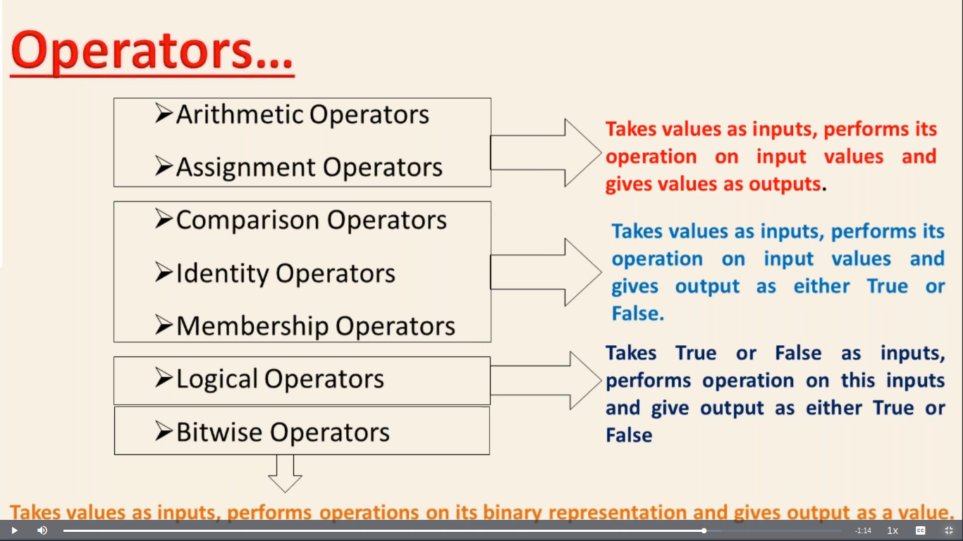
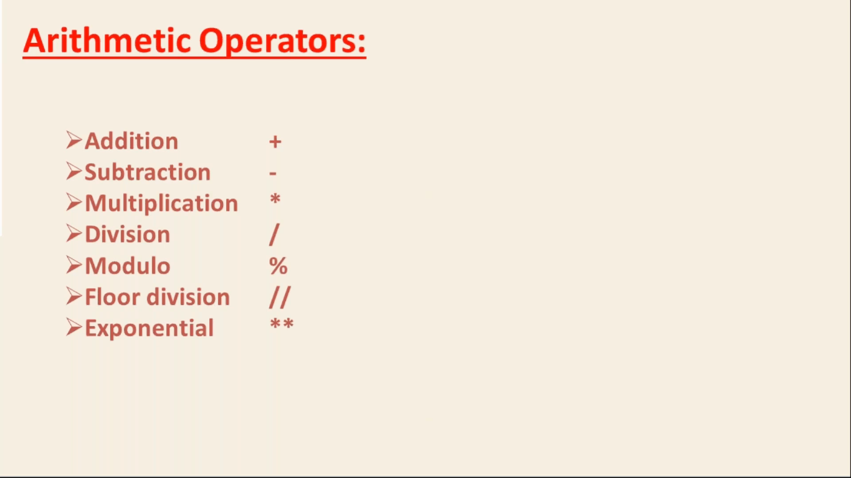

ord(‘<character>’) - to find the ascii code

char(<ascii code>) - to get the character

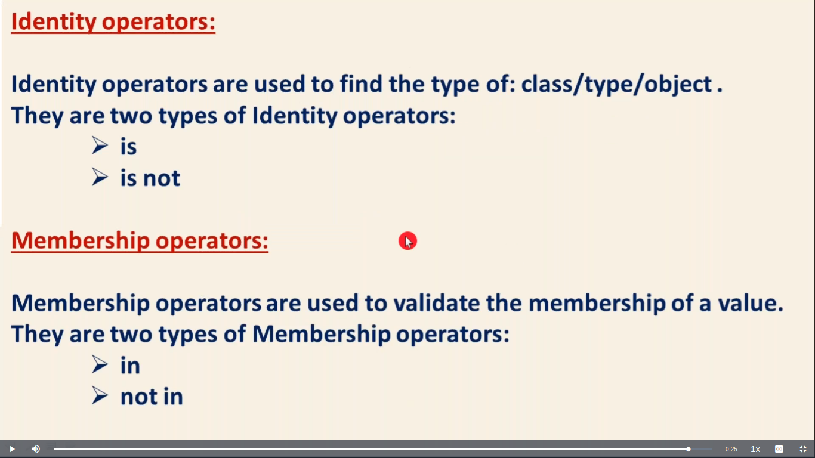
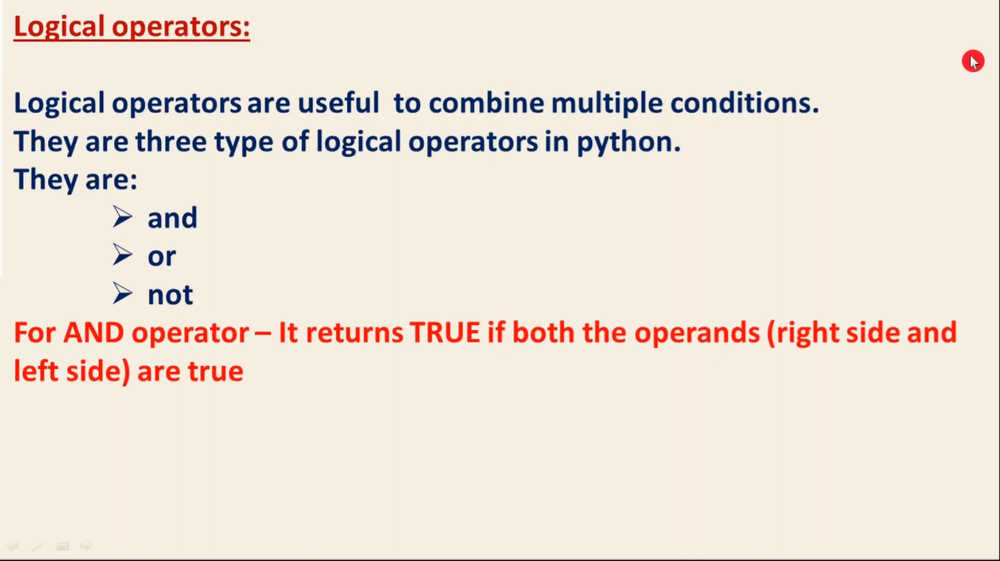

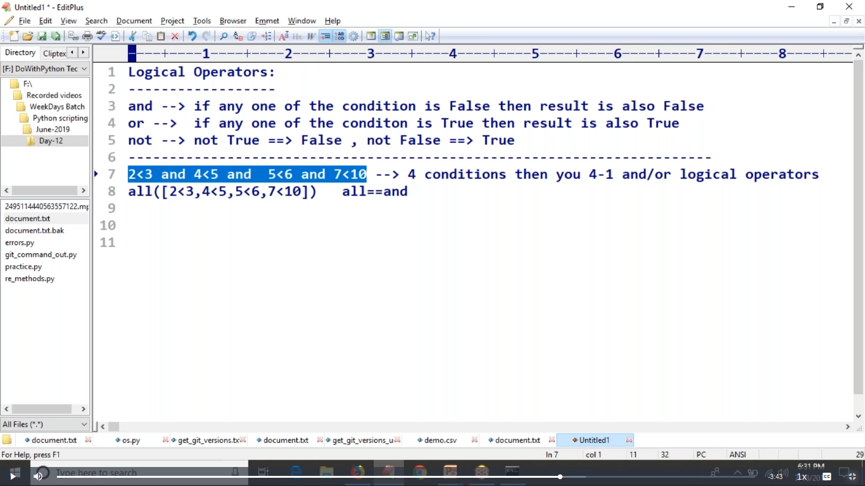

all = and

any = or

Conditional Statements

if condition1:
statements
elif condition2:
statements
elif condition3:
statements
else
statements

Python Modules

import math

print(math.pow(2,3))

print(math.pi)

print(math.factorial(4))

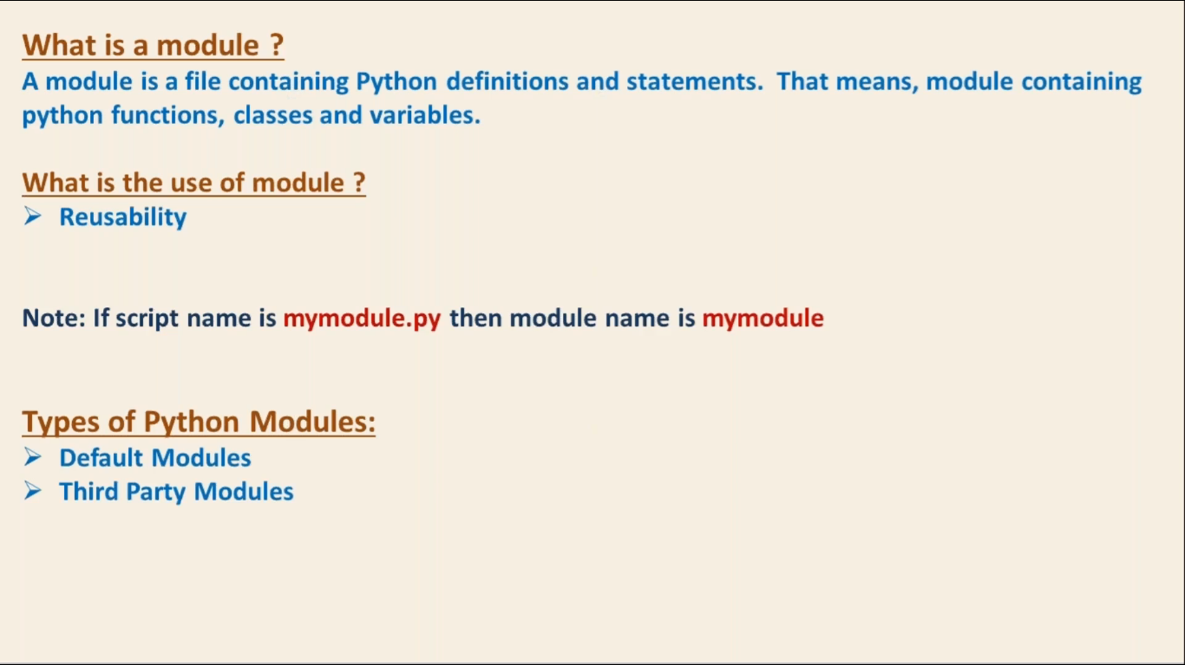

from math import *
print(pow(2,3))

from math import pi
print(pi)

import math as m
print(m.pow(2,3))
print(m.pi)

import platform,os,math,sys

